Chapter 1- The Human Body: An Orientation Notes
I. Overview of Anatomy and Physiology—
a. Anatomy studies _______________________________________
b. Physiology studies _____________________________________
c. “Structure determines function” means:____________________________________
_________________________________________________________________________________
II. Levels of Structural Organization
Chemical level-
- atom-
- molecule-
- organelle-
Cellular level-
- cell-
- tissue-
- organ-
- organ system-
Organismal level
h. organism-
III. What is Life?
Characteristics of living things:
1. 5.
2. 6.
3. 7.
4. 8.
All of these characteristics depend upon ________________ and ________________ changes that occur within body parts. These changes are called __________________.
IV. Survival Needs of Organisms
_______________________ and ________________________ are both important.

Organisms need these things to survive:
1. 3. 5.
2. 4.
V. Homeostasis
Communication within the body is essential for __________________________. It is accomplished chiefly by the ________________________ and _________________________ systems that use ________________________ signals delivered by ___________________ or blood borne ______________________ as information carriers.
The factor/event being regulated in the body is called the ________________________.
All homeostatic control mechanisms have at least 3 components:
1.
2.
3.
There are 2 pathways that information follows within this mechanism:
- afferent- from ___________________ to ___________________________
- efferent- from ___________________ to ___________________________
The results of the response “feed back” to ________________ or ______________ the stimulus.
Positive feedback is when the stimulus ___________________________________.
Negative feedback is when the stimulus __________________________________.
A. Positive Feedback
- Always ________________________ the original stimulus; called “cascade”
- Not used for ___________________________ well-being.
- Produces _______________________ body conditions and can cause _________________.
- Examples of positive feedback_______________________________________________
B. Negative Feedback
- Responds by __________________ the original stimulus; used in making adjustments for moment-to-moment well-being of body
- Returns body to ____________________ state
- The goal of negative feedback is to prevent sudden ___________________ in the body.
- Examples of negative feedback_________________________________________________
Explain the steps of a specific negative feedback mechanism from the text. (p. 9-10)

VI. Organ System Overview (p. 6-7 in text)
System | Functions | Organs
Skeletal

Muscular

Nervous

Integumentary

Endocrine

Cardiovascular

Lymphatic

Respiratory

Digestive

Urinary

Reproductive

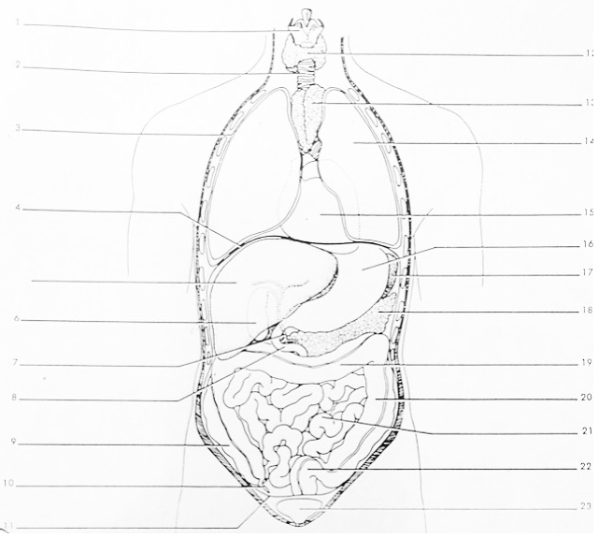
Label the torso above using the terms in the chart. (Use p. 857 to label diagram)
Organ/Structure | Function | Body System  (for organs only)
Larynx
Trachea
Lungs (R & L)
Diaphragm
Liver
Gallbladder
Cystic Duct
Duodenum
Large Intestine
-Ascending Colon
-Transverse Colon
-Descending Colon
-Sigmoid Colon
Appendix
Mesentery
Thyroid
Thymus Gland
Heart
Stomach
Spleen
Pancreas
Small Intestine
Urinary Bladder
VII. Overview of Body Cavity Arrangement and Membranes
BODY CAVITIES (use diagram p. 17)

DORSAL | a.
 | b.
VENTRAL | a. Facial | 1. (eye)
 |  | 2. (ear)
 |  | 3. (nose)
 |  | 4. (mouth)
 | b. Thoracic | 1.
 |  | 2.
 | Divided by the DIAPHRAGM
 | c. Abdominopelvic | 1.
 |  | 2.
True body cavities are “closed” cavities. Cavities with 1 end open to outside are “open” cavities.
BODY MEMBRANES (p. 17-18)
I. Mucous- lines both __________________ and ____________________ cavities.
Thick, used as a lubricant in the body.
II. Serous- lines ______________________ cavities ONLY.
Thin, watery
2 Types of Serous Membranes:
- Parietal- lines ___________________ of cavity.
- Visceral- lines ___________________ in cavity.
Named According to LOCATION:
- Abdominal= peritoneum
- Lungs= pleural (singular is pleura)
- Heart= pericardium
EXAMPLES:
- Membrane on the surface of the lung = _______________________________________
- Membrane on the surface of the heart= ______________________________________
- Membrane on the wall of the abdominopelvic cavity= ____________________________________________________________________________________
- Membrane on the surface of the stomach= ____________________________________________________________________________________
VIII. Anatomical Position/Body Planes/ Directional Terms
Anatomical position is standing, with feet flat on the floor, and palms (anterior) surfaces facing forward.
The body can be divided into several planes (sections): (use diagrams p. 16)
Plane | Divides Body Into:
1. Sagittal
a. Mid-sagittal
(median)
b. Parasaggital
2. Frontal
(coronal)
3. Transverse
(cross-section)
4. Oblique

Directional Terms (table p. 13)

Term | Definition
Superior (Cranial)
Inferior (Caudal)
Anterior (Ventral)
Posterior (Dorsal)
Medial
Lateral
Intermediate
Proximal
Distal
Superficial (External)
Deep (Internal)
Supine
Prone

Practice: Describe the anatomical relationship(s) that exist between each of the following parts. (There may be more than one answer for some of them). Always assume the body is in anatomical position.
1. elbow and wrist- 11. brain to spinal cord-
2. nose and chin- 12. wrist to hand-
3. skin and kidneys- 13. fingers to hand-
4. lungs and heart- 14. kneecap to knee joint-
5. toes to ankle- 15. eyes to nose-
6. scalp to skull- 16. ears to head-
7. diaphragm to lung- 17. thumb to hand-
8. heart to diaphragm- 18. little toe to big toe-
9. head to neck- 19. eyebrow to eye-
10. esophagus to spine- 20. inside corner of eye to
outside corner of eye-

IX. Abdominopelvic Regions (p. 19) “tick-tack-toe” board on abdomen
Identify Major Organs in Each Region
R Hypochondriac | Epigastric | L Hypochondriac
R Lumbar | Umbilical | L Lumbar
R Iliac (Inguinal) | Hypogastric (Pubic) | L Iliac (Inguinal)

X. Body Regions (p. 12)- Will be covered in lab manual

