Body Cavities and Membranes
I. The human body can be divided into two main cavities, the dorsal cavity (back side) and the ventral cavity (belly side).
A. Dorsal body cavity-protects organs of the nervous system and has two subdivisions:
1. The cranial cavity is the area within the skull and contains the brain.
2. The spinal (vertebral) cavity contains the vertebral column and spinal cord.
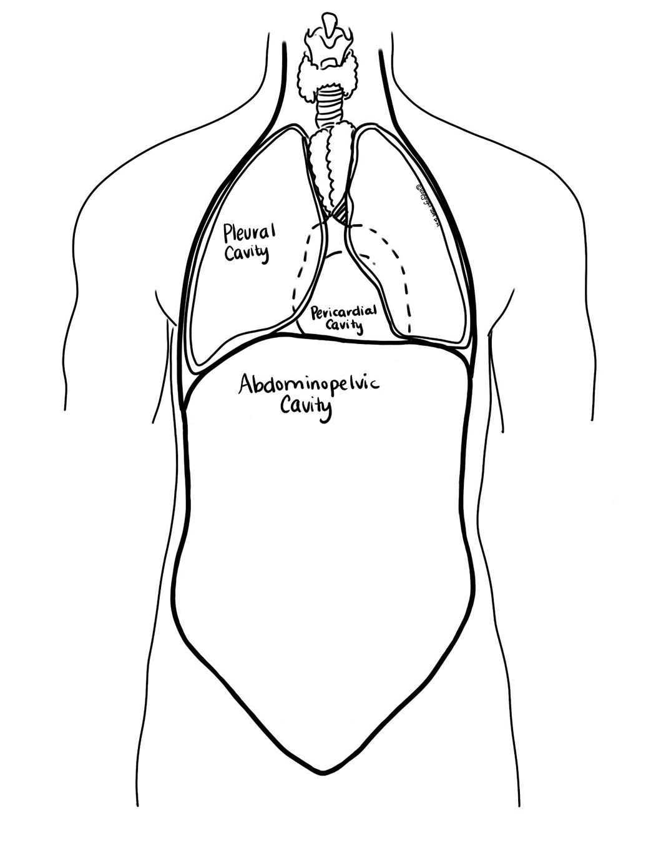
B. Ventral body cavity-protects most of the organs in the body and consists of two major subdivisions, the thoracic and abdominopelvic cavities, and several minor body cavities including the orbital (contains the eyes), nasal (contains a respiratory and olfactory region), oral (contains tongue, teeth, and gums), and otic (middle ear bones). The 2 major subdivisions are: (see Figure 1-5)
1. The thoracic cavity is the superior division and is surrounded by the ribs and muscles in the chest. It is further subdivided into:
a. Two lateral pleural cavities (each pleural cavity contains a lung) and the mediastinum (a wedge-shaped cavity located between the superior regions of the two thoracic cavities that contains the esophagus, thymus gland, and trachea).
b. The pericardial cavity lies within the mediastinum in the center of the chest. It contains the heart.
2. The abdominopelvic cavity is the inferior division and is separated from the thoracic cavity by the diaphragm. It has two major subdivisions:
a. Abdominal cavity-contains the kidneys, ureters, stomach, spleen, liver, intestines, gallbladder, and pancreas.
b. Pelvic cavity-contains the urinary bladder, rectum, anus, and reproductive organs.
Figure 1-5
II. The body cavities are lined with thin sheets of tissue called membranes, which cover a structure or line a cavity.
The body’s membranes are classified into 2 broad categories:
- Epithelial membranes-cutaneous (skin), mucous (mucosa), and serous (serosa); most are moist (except skin).
- Synovial membranes-lack epithelium; provide a smooth surface and cushioning through synovial fluid; found at joints.
A. The dorsal body cavity is lined with three layers of protective membranes (the dura mater, arachnoid, and pia mater), which are called the meninges. They cover the brain and spinal cord.
B. The ventral body cavity contains cavities which are considered either open (to the air) or closed (not exposed to the air).
1. Open cavities-lined with mucous membranes (mucosa); include the hollow organs of the respiratory, digestive, urinary, and reproductive tracts.
2. Closed cavities-lined with double-layered serous membranes (serosa) separated by serous fluid, a watery substance that allows for lubrication and movement of organs. The inner membrane (visceral) clings to the organ and the outer membrane (parietal) lines the wall of the cavity. They are named according to their location:
a. Pleura-membrane that lines the pleural cavity, which covers the lungs in the thoracic cavity.
b. Pericardium-membrane that lines the pericardial cavity, which covers the heart in the mediastinum (middle part of the thoracic cavity).
c. Peritoneum-membrane that lines the abdominopelvic cavity and many of the organs found within it.
C. Naming and Terminology
1. The visceral layer of the membrane is the layer that touches the organs. Viscera means “organ”.
2. The parietal layer is the layer that forms the outer shell of the membrane and touches the surrounding structures, and lines the wall of the cavity. Parietal comes from a Latin word that means “wall”.
3. Typically, the serous membranes are named according to the cavity and organ with which they are associated. For example, the parietal pericardium lines the pericardial cavity and the visceral pericardium clings to the surface of the heart.

Body Cavities (Figure 1-6)
Cavity | Color
Cranial
Spinal (Vertebral)
Thoracic
Abdominal
Pelvic
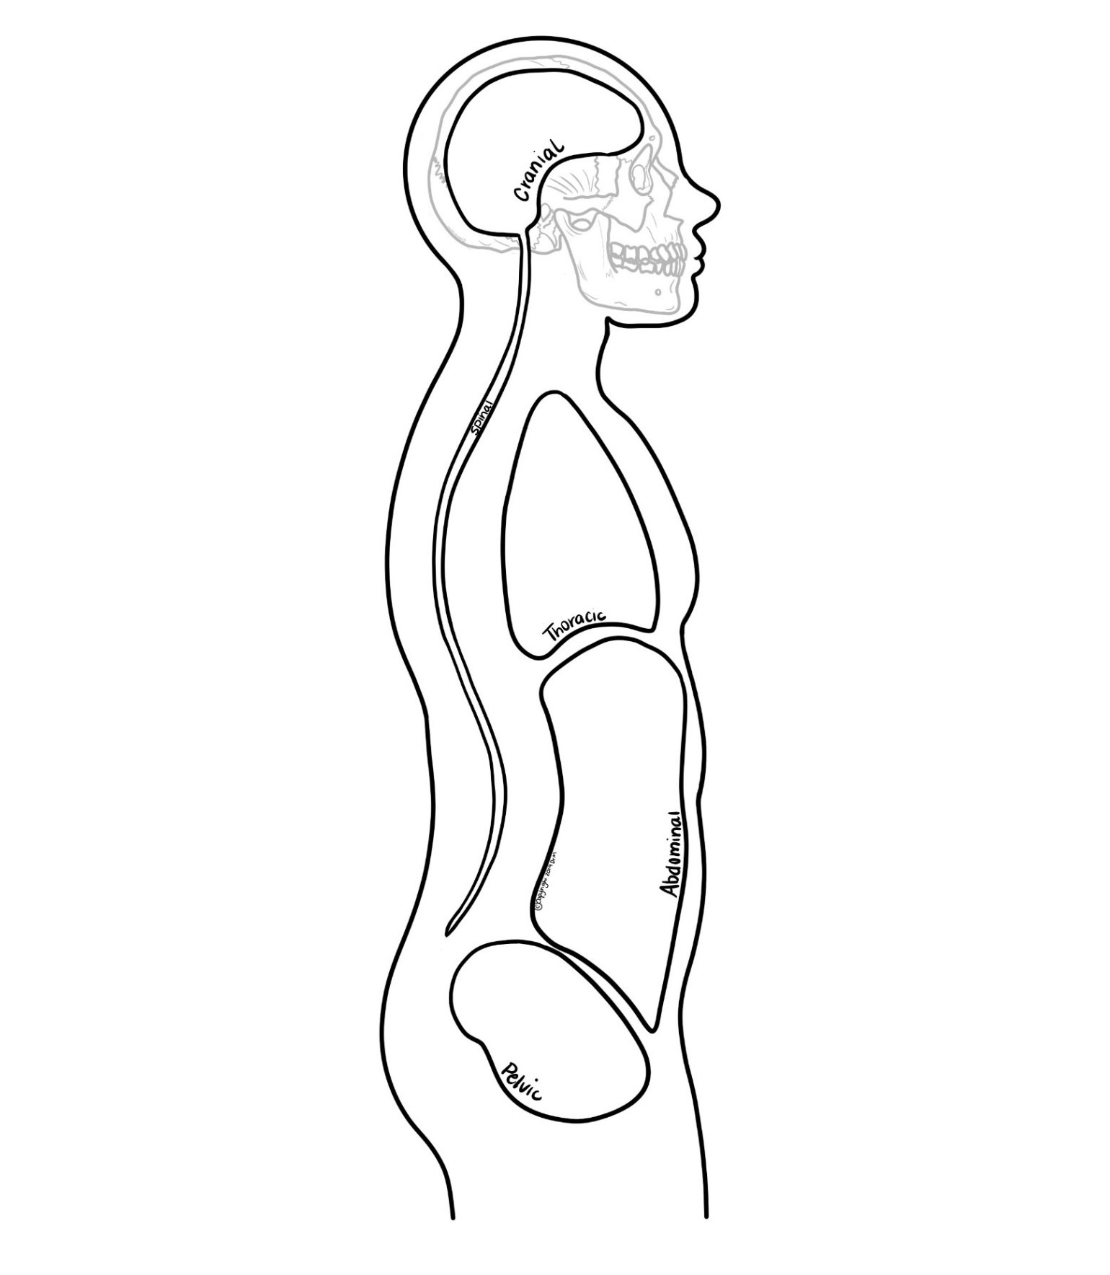
Figure 1-6

Body Cavities and Membranes (Figure 1-7)
Use Figure 1-7 to help you visualize the arrangement of the body cavities. Color the body cavity, then outline the cavity with a contrasting color to represent the membrane that lines the cavity. Refer to pgs. 11-12 if you need additional assistance.
Cavity | Location (Dorsal or Ventral) | Membranes that Line this Cavity (Meninges, Serous, or Mucosa) | Organs/ Structures In this Cavity | Color
Cranial
Spinal (Vertebral) |  |  |  | Not shown in Figure 1-7
Thoracic
Oral
Otic
Nasal
Orbital
Cardiac (in Thoracic)
Mediastinum (in Thoracic)
Pleural (in Thoracic)
Abdominal
Pelvic

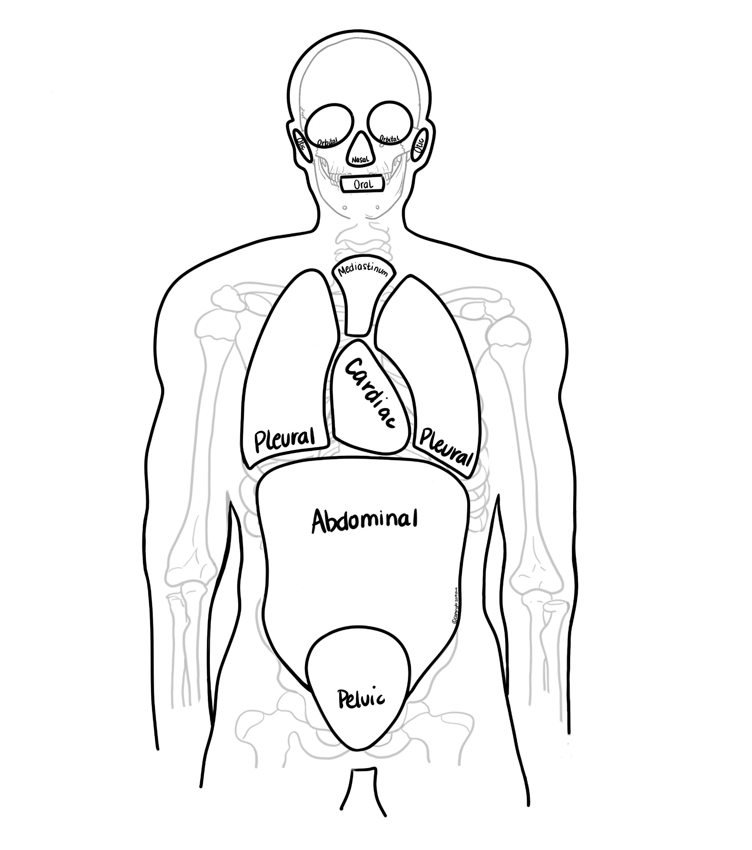
Figure 1-7
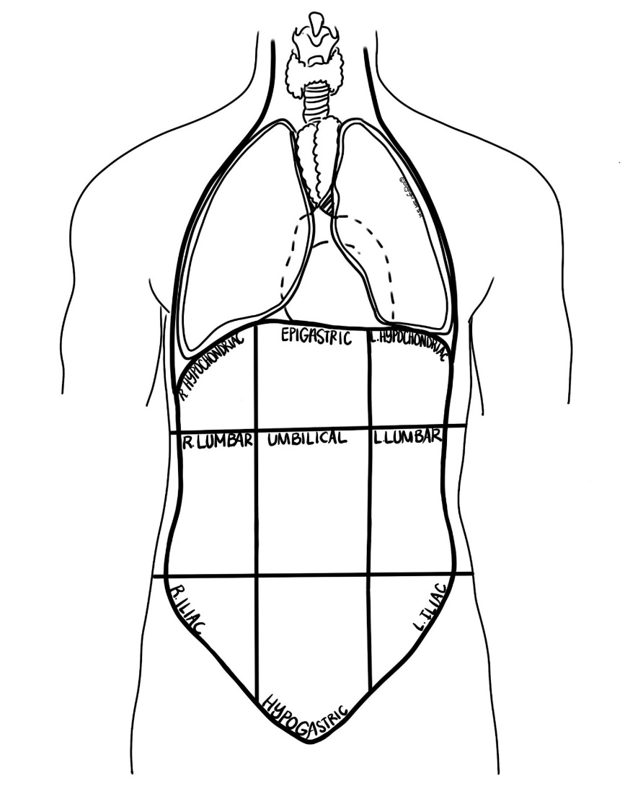
Abdominopelvic Regions
The regions of the abdomen are divisions used by physicians to help localize, identify and diagnose a patient’s symptoms. There are two main forms of categorization: one that divides the abdomen into four quadrants and the second that divides it into nine regions. The method which divides the abdomen into 9 regions can further localize clinical symptoms to help physicians arrive at an accurate diagnosis more quickly.
The right and left hypochondriac regions are found superiorly on either side of the abdomen, while the epigastric region is located between them in a central, superior position. The right and left lumbar regions surround the central umbilical region that has the umbilicus (bellybutton or navel) as its center point. Finally, the right and left iliac regions are located inferiorly on either side of the hypogastric region, the most inferior of the central line of segments. (see Figure 1-8)

Figure 1-8
Most organs in the abdominopelvic cavity are part of multiple regions.
1. The right hypochondriac region contains parts of the liver, gallbladder, small intestine, and the right kidney, while the left hypochondriac region contains part of the spleen, colon (large intestine), pancreas, and the left kidney.
2. The epigastric region, located between the right and left hypochondriac regions, contains the majority of the stomach, as well as parts of the liver, pancreas, duodenum, spleen, and the adrenal glands.
3. The central umbilical region, located just inferior to the epigastric region, contains the umbilicus (navel), in addition to parts of the small intestine (duodenum, jejunum, and ileum).
4. It is flanked on either side by the right lumbar region containing the gallbladder, ascending colon, and the right kidney, and the left lumbar region which contains the descending colon, left kidney, and part of the spleen.
5. The lowest regions, the right and left iliac, are sometimes referred to as the inguinal regions. The right iliac region contains the appendix and cecum, while the left iliac region contains part of the descending colon and the sigmoid colon.
6. The central hypogastric region contains organs around the pubic bone including the urinary bladder, anus, and the reproductive organs.

Abdominopelvic Regions (Figures 1-8 and 1-9)
Color Figure 1-8 on p. 16 and record your color choice in the chart below. Use the same colors to outline the corresponding region in Figure 1-9. Record the organs present in each abdominopelvic region using pgs. 16-17.

Region | Organs in this Region | Color
Right Hypochondriac
Epigastric
Left Hypochondriac
Right Lumbar
Umbilical
Left Lumbar
Right Iliac
Hypogastric
Left Iliac

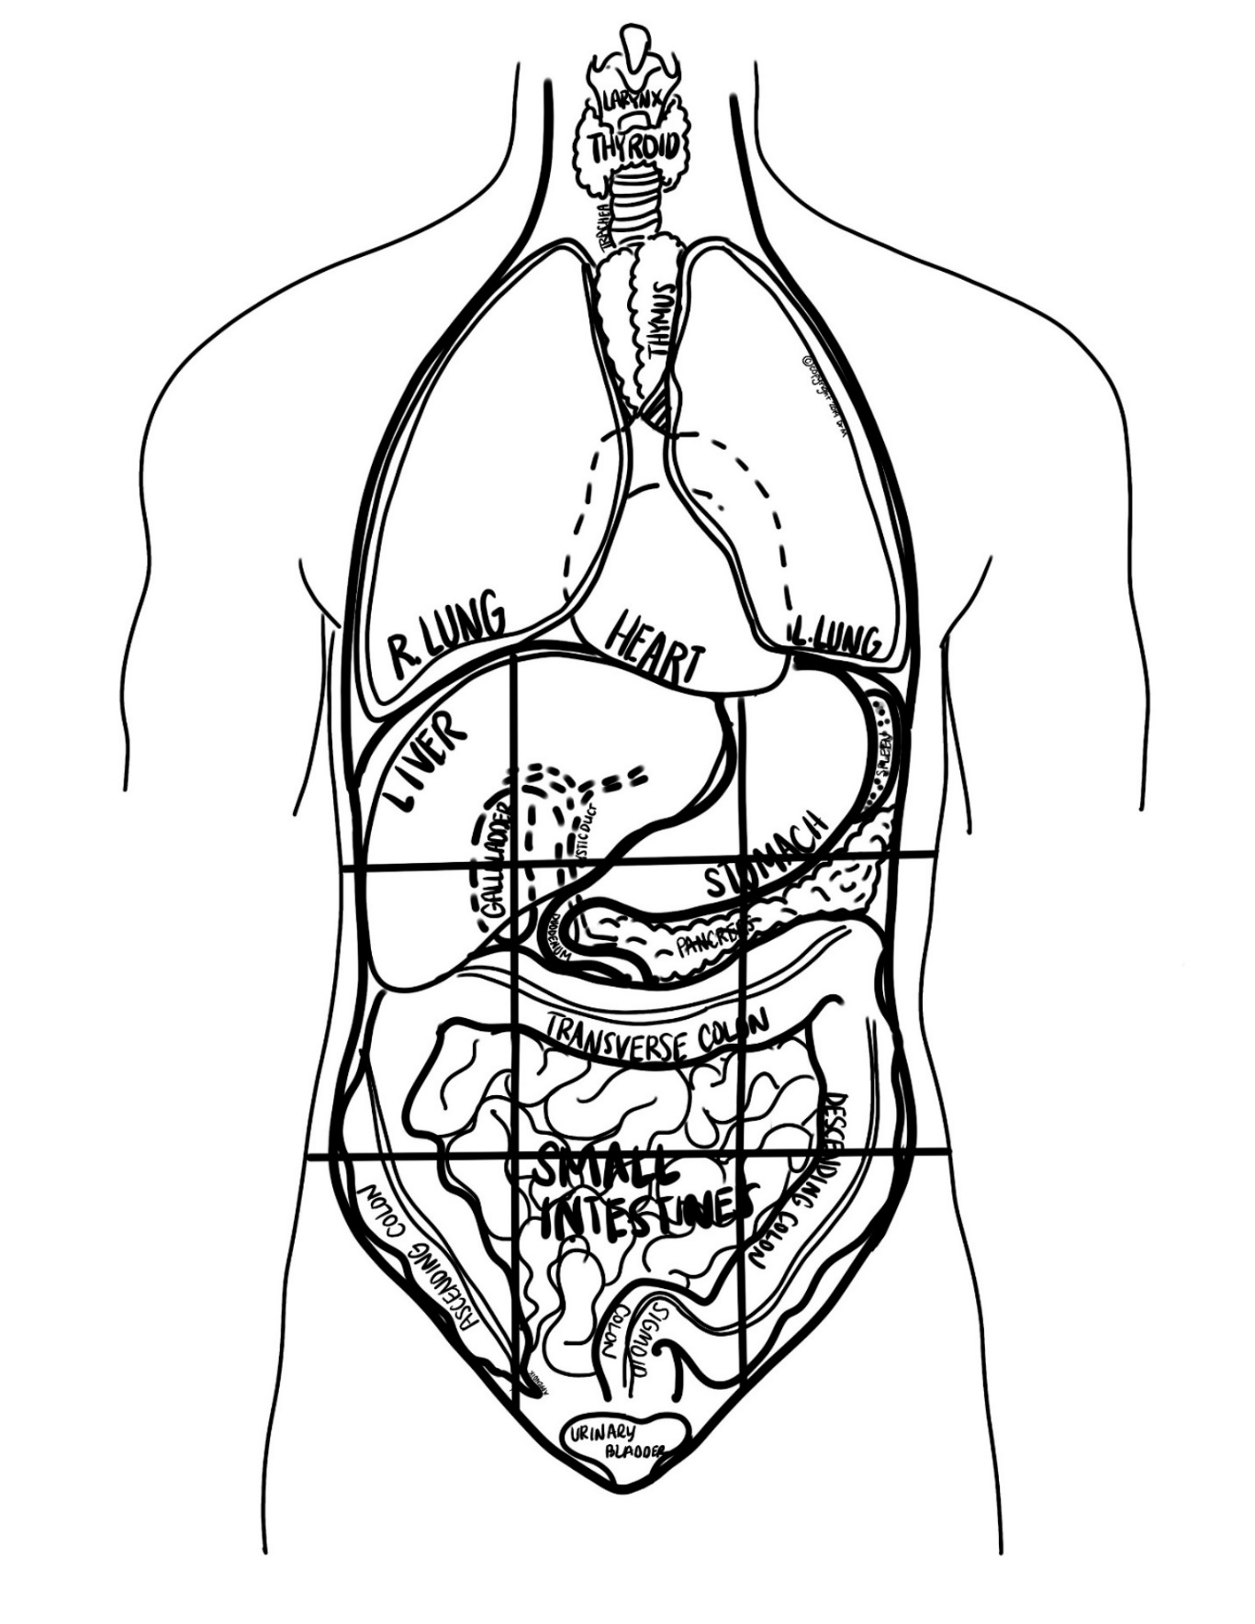

Figure 1-9

Organ System Overview
This chart provides the major functions and organs/structures for each body system. The function of the organ/structure is stated in parentheses after the name.
System | Organs | Functions
Skeletal | - Bones along with cartilage, ligaments, and joints (body support) | - Supports body  - Site of skeletal muscle attachment  - Stores minerals  - Protects form blood cells
Muscular | - Muscles-smooth, cardiac, & skeletal (movement) | - Movement  - Maintain posture  - Produces heat
Nervous | - Brain (control of body)  - Spinal cord (relay messages between body and brain)  - Nerves (conduct impulses between body and brain)  - Sensory receptors such as eye, ear, tongue (receive information from surroundings and generate nerve impulses to brain) | - Rapid response to stimuli
Integumentary | - Skin (protection) | - Covers body  - Protection  - Makes vitamin D  - Contains receptors & glands
Endocrine | - Glands | - Secretes hormones that regulate processes
Cardiovascular | - Heart (pumps & circulates blood)  - Red Blood Cells (carry O₂, nutrients, hormones to/from tissues for exchange)  - White Blood Cells (protection and immunity) | - Transports nutrients, O₂, and hormones to cells  - Removes metabolic wastes
Lymphatic | - Lymphatic vessels (tubes for fluid to return from blood)  - Lymph nodes (cleanse blood, house immune cells)  - Lymphoid organs including spleen (filters blood) and tonsils (gather and removes pathogens) | - Returns interstitial fluid leaked from blood to blood vessels  - Transports WBC to and from lymph nodes into bones  - Complements Cardiovascular system
Respiratory | - Nasal passages (inhale air)  - Pharynx (throat, passageway for air)  - Larynx (speech)  - Trachea (passageway for air)  - Bronchi (tubes leading to lungs for air passage)  - Lungs (O₂/CO₂ exchange)  - Diaphragm (muscle that aids breathing) | - Supply O₂  - Remove CO₂
Digestive | - Mouth (take in food)  - Esophagus (tube to stomach)  - Stomach (chemical & physical digestion)  - Small intestine (absorbs nutrients)  - Large intestine/Colon (absorbs, transports waste, reclaims H₂O)  - Rectum (waste storage before excretion)  - Liver (detoxifies blood)  - Cystic duct (tube bile travels through when secreted into duodenum)  - Pancreas (produces insulin and other enzymes that break down food)  - Gallbladder (stores bile)  - Appendix (pouch of large intestine that contains lymphoid tissue)  - Duodenum (1st part of small intestine and location where digestive enzymes & bile secreted) | - Break down food (mouth small intestine)  - Reclaim H₂O (large intestine)
Urinary | - Kidney (filters blood & removes toxins)  - Ureter (tube from kidney to bladder)  - Urethra (tube from bladder out of body)  - Urinary Bladder (urine storage) | - Remove nitrogenous waste from blood  - Salt/ electrolyte balance  - Acid/base balance of blood
Reproductive | Male  - Testes (produce sperm & testosterone)  - Penis (delivers sperm to female)  - Accessory glands (produce seminal fluid)  - Duct System (transports sperm)  Female  - Ovary (produces eggs)  - Fallopian Tubes (transport sperm towards egg)  - Uterus (womb that holds fetus during pregnancy)  - Vagina (canal that receives sperm) | - Produce offspring via sperm (male) and egg (female)

Major Organs and Functions (Figure 1-10)
Complete this chart by supplying the function of each organ as well as the body system to which it belongs. On Figure 1-10, color or outline each organ of the same system using the same color. Use the Organ System Overview chart on pgs. 20-21 for reference.
Organ/Structure | Function/ Description | Body System | Color
Larynx
Trachea
Lungs (R & L)
Liver
Gallbladder
Cystic Duct
Duodenum
Large Intestine (Ascending, Transverse, Descending, and Sigmoid Colon)
Appendix
Heart
Stomach
Spleen
Pancreas
Small Intestine
Urinary Bladder

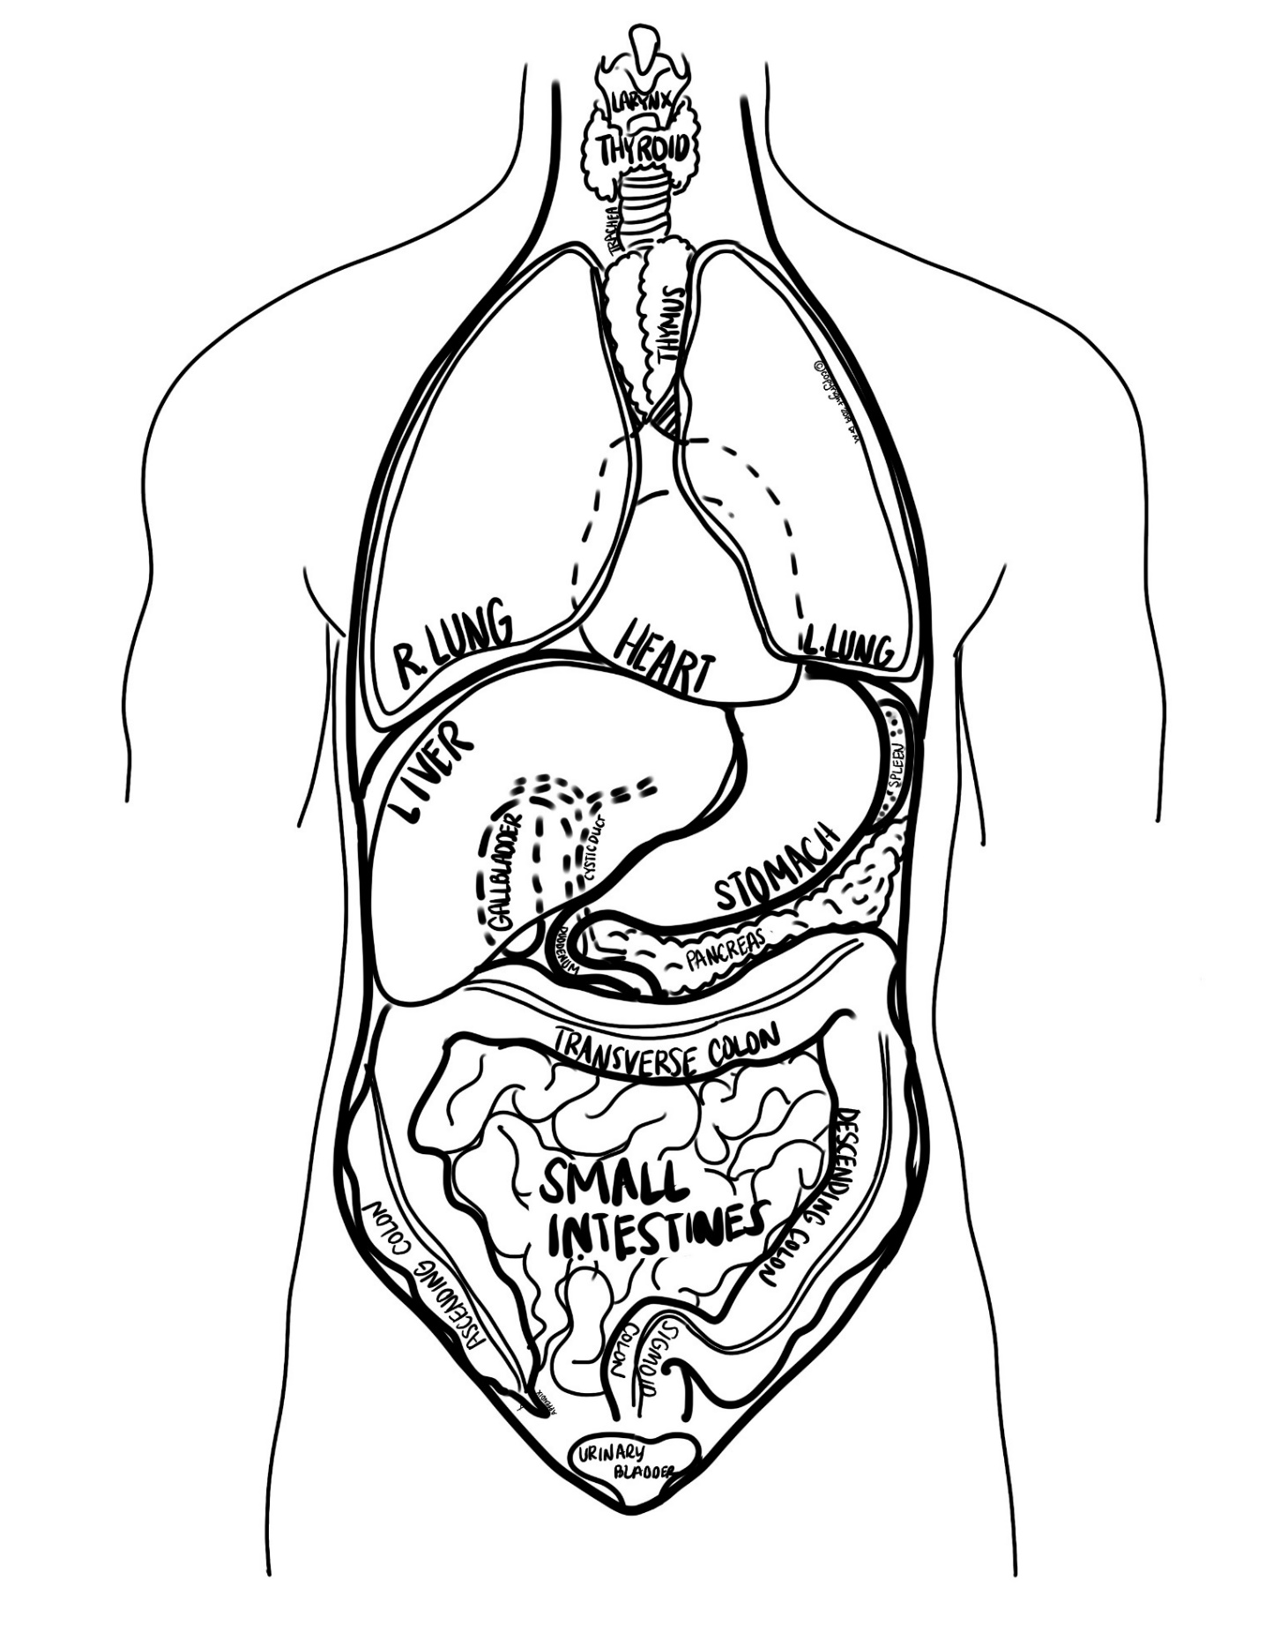
Figure 1-10

Body Planes & Directional Terms
Anatomical position is standing, with feet flat on the floor, and palms (anterior) surfaces facing forward. The body is always assumed to be in anatomical position when describing things in anatomical language.
I. Body Planes-The body can be divided into several planes/sections. (see Figure 1-11)
Plane | Divides Body Into:
1. Sagittal/ Mid-sagittal (median)
2. Frontal (coronal)
3. Transverse (cross-section)
4. Oblique
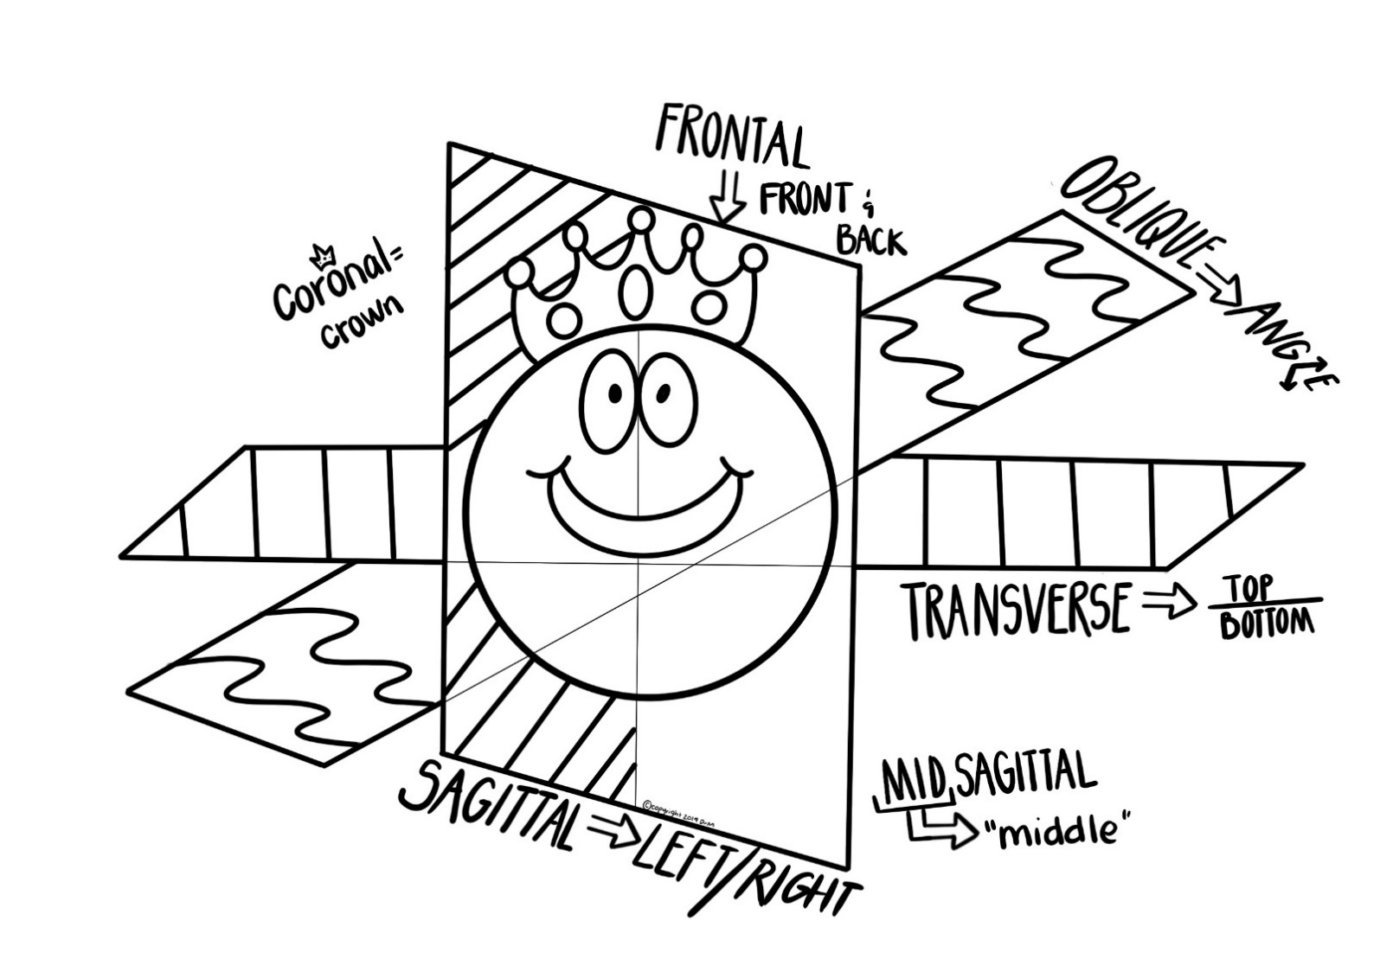
Figure 1-11

II. Directional Terms (use Figure 1-12 p. 27 for reference)
Helpful hint: It is easier to remember the directional terms as opposites as they appear on this chart.
Directional Terms
Term | Definition
Superior (Cranial)
Inferior (Caudal)
Anterior (Ventral)
Posterior (Dorsal)
Medial
Lateral
Intermediate
Proximal
Distal
Supine
Prone
Superficial (External)
Deep (Internal)

III. Practice
Practice: Describe the anatomical relationship(s) that exist between each of the following parts. (There may be more than one answer for some of them). Always assume the body is in anatomical position. Answer should fit into the statement “The ___ is ___(anatomical term) to the ____” Refer to chart on p.25 as well as Figure 1-12 for reference.
1. elbow and wrist- 11. brain to spinal cord-
2. nose and chin- 12. wrist to hand-
3. skin and kidneys- 13. fingers to hand-
4. lungs and heart- 14. kneecap to knee joint-
5. toes to ankle- 15. eyes to nose-
6. scalp to skull- 16. ears to head-
7. diaphragm to lung- 17. thumb to hand-
8. heart to diaphragm- 18. little toe to big toe-
9. head to neck- 19. eyebrow to eye-
10. esophagus to spine- 20. inside corner of eye to outside corner of eye-

Figure 1-12

